MIDTOWNERS SUNSHINE OF THE WEEK ► February 15, 2008
Birthday of PP Rtn Niranjan Pradhan on February 20th
Birthday of Kamala Shrestha, spouse of PE Rtn RR on February 15th
Birthday of Marianne Sunde, spouse of Rtn Luke on February 18th
Anniversary of Rtn. Govinda and Usha Chipalu on February 17th
Anniversary of Rtn. Rabindra and Reena Shrestha on February 18th
Anniversary of PP Rtn Ajaya and Sunila Sthapit on February 18th

SPEAKER OF THE WEEK ► Mr. John Fry
THEME | The Changing Role of the British Council in Nepal
John Fry is currently Country Manager of the British Council in Nepal. An English language teacher by profession, John has worked for the British Council in Hong Kong (twice), China, Japan, Greece, Malaysia and Italy.

UPCOMING SPEAKERS ► PREVIEW
DATE | SPEAKER | THEME
Feb 22nd | Sirish Bhattarai | Vehicle Pollution Control
Feb 29th | Peter Morris
Mar 7th | Vacant | Vacant

THE MID-TOWN CLUB ► NEWS
Previous Club meetings
On January 28th, there was a joint meeting with clubs from Zone II held at Hotel Shankar. At the meeting, guest speaker Rtn Robert Rose from District 5030 talked about a very ambitious Rotary project to help uplift people with disabilities in Nepal. The project is planned in partnership between District 5030 from the Seattle area District 5030 and Rotary Clubs from our very own District 3292 to develop and implement projects to help people with disabilities in Nepal. One component of the project is a $330,000 Rotary Foundation 3-H grant to fund an overall awareness program to help change the negative attitudes and superstitions toward those with disabilities in Nepal.
On February 1st, our youth exchange student from USA (sponsoring club Phillipsburg) Chandra Morgan gave a talk on her experience with the program and what she expects to achieve by the end of it next summer.

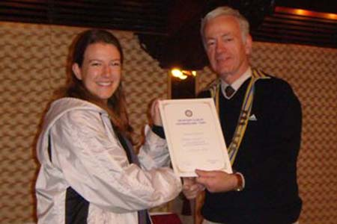  President Walter handing letter of appreciation to Guest Speaker Chandra Morgan |  | 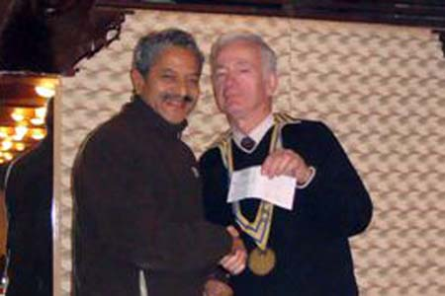  Rtn Pratap Malla handing a cheque of US $1000 from his son Jay Malla for our RCC project in Lele
Polio Eradication: II NID Day
The second round of NID was held on Saturday, February 2nd, 2008. Our Club was assigned to cover the following booths in two areas:
- Ward No 35 in Koteswar area (25 booths)
- Thankot bus stop area

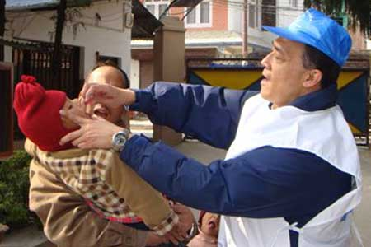 | 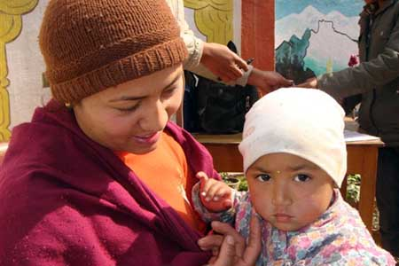 |  | 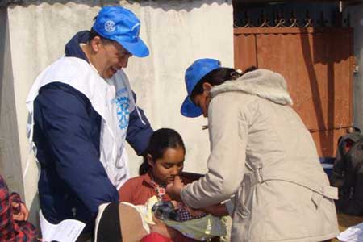

THE ROTARY INTERNATIONAL ► NEWS
UN secretary-general meets with Rotary leaders
United Nations Secretary-General Ban Ki-moon met with Rotary leaders and praised Rotarians for their commitment to polio eradication in a recent visit to Chicago.
“Rotary International has led a worldwide campaign to wipe out polio. Sometime soon, their work will be done. Polio will be history, like smallpox,” Ban said in an address to the Economic Club of Chicago on 7 February.
At a private ceremony in downtown Chicago earlier in the day, Rotary International President Wilfrid J. Wilkinson presented Ban with the Rotary International Award of Honor in recognition of his support for polio eradication and his dedication to furthering peace and cross-cultural understanding. Past recipients of this high Rotary honor include Kofi Annan, Bill Clinton, Mikhail Gorbachev, and Nelson Mandela.
The secretary-general also met with Foundation Trustee Chair Robert S. Scott, RI General Secretary Edwin H. Futa, and RI President-elect Dong Kurn Lee. Ban and Lee, both South Koreans, are friends.
Rotary's close ties with the UN date back to 1945 when 49 Rotarians helped draft the UN charter. Rotary continues to collaborate with the UN through the Global Polio Eradication Initiative, a partnership with the United Nation's Children’s Fund, the World Health Organization, and the Centers for Disease Control and Prevention.

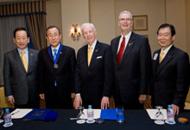
From left to right: RI President-elect Dong Kurn Lee,
UN Secretary-General Ban, RI President Wilfrid J. Wilkinson,
Foundation Trustee Chair Robert S. Scott, and
RI General Secretary Edwin H. Futa.
By Susie Ma
Rotary International News - 8 February 2008

Editor: Rabi Karmacharya, Club Service Director email: rabikarma@gmail.com

----- Original Message -----
From: "Rabi Karmacharya" <rabi@himalayantechies.com>
To: <undisclosed-recipients:>
Sent: 14 February, 2008 0:45
Subject: BC Vol 19 07-08.doc

> Please enjoy the latest edition of the BC.
>
> YIR,
> -Rabi

